Maksim KOPTELOV

June 2016

**Dynamic texture modeling and synthesis using   
Multi-kernel Gaussian process   
Dynamic model**

University of Jean Monnet

Master 1 MLDM

Academic Supervisors:

Assoc. prof. Marianne CLAUSEL

Assoc. prof. Rémi EMONET

Prof. Olivier ALATA

# Introduction

Our world is full of examples of dynamic textures. Any visual scene can be considered as dynamic texture. What is a definition of texture? For a single image a texture is a realization from stationary stochastic process. For a sequence of images this texture becomes dynamic by defining the stochastic process of interest over space and time.

Why is it important to study dynamic textures? There are many applications, which can be found in computer vision and video processing fields. Some of them are: video indexing, video surveillance, object tracking and video animation [2].

Existing researches [1] shows that dynamic texture can be captured from a video and can be used then to synthesize new videos with necessary length of time. Existing dynamic textures modeling and synthesis methods can be summarized into three categories: physics based, sampling based and learning based methods [1].

Physics based methods synthesize dynamic texture by modeling the physical mechanism of some specific phenomena. The advantage is the quality of the result, which can be obtained, however these methods are not universal and the computation cost for a single texture is extremely expensive [1].

Sampling based methods reassembles the sequence of frames taken from original video to form a longer sequence with unnoticeable transitions. They require to storage large amounts of original frames and cannot generate a texture frame unseen [1].

Learning based methods assume specific model linking the different frames of the video and learn its parameters. Once all parameters are learnt the information from the model can be used to synthesize new videos. Compared with other two types of methods, they are universal. Moreover, these methods only require few memory space for dynamic texture synthesize and can achieve high data compression.

Thus, in this work learning based method is used for dynamic texture synthesis. The method proposed consists of three imperative steps:

1. Dimensionality reduction,
2. Dynamic texture learning
3. Dynamic texture synthesis.

Any video sequence has high dimensionality, thus curse of dimensionality problem will be faced (data becomes too sparse and distance functions become not accurate). To prevent it dimensionality reduction process must be applied. As an algorithm, it can be linear (like PCA) or nonlinear. However, linear algorithms cannot capture complex dynamic textures and some nonlinear algorithms produce irreversible mapping or different coordinate systems [1]. Thus, it is necessary to find an algorithm, which is free of these weak points. In this work, the reduction function is inferring by using Gaussian process.

The algorithm for learning of dynamic texture cannot be linear due to the fact that most of dynamic textures are not linear. It can be switching or piecewise linear, but in this case it would not be universal, because it does not suite for all dynamic textures. Thus, more flexible model must be found. In this work, dynamic texture is modeling using first-order Markov model based on Gaussian process [1].

Dynamical texture synthesis step generates new video data using learned dynamic texture. It can be done by estimate necessary parameters (latent variable vector, observed dynamic texture vector, kernel matrix mapping hyperparameters, weights for kernel functions and different kernel parameters), then by predicting new sequence of dynamic textures. It is necessary to have a good performance at this step due to the big computational cost of optimization. In this work, mean-prediction method based on first-order Markov model using Gaussian prediction is adopted for dynamical texture synthesis [1].

# Context of the project

The grant for the project is provided by Laboratoire Jean Kuntzmann (LJK). Located in Grenoble the LJK is a laboratory of Applied Mathematics and Computer Science. It brings together teams of different branches: mathematicians, numerical analysts, computer graphics, image processing and computer vision specialists. Three main departments represent the organization of the laboratory:

* The Probability / Statistics department
* The Geometry-Image department
* The department of Models and Deterministic Algorithms.

My chief supervisor, associate professor Marianne CLAUSEL, is a member of the Optimization and Learning for Data Science team (DAO) of the LJK. The research topics of the DAO team are focused around mathematical methods for data science capitalizing on the interplay between mathematical optimization and machine learning. Main research themes are:

* Convex and stochastic optimization
* Distributed, incremental, and randomized numerical algorithms
* Robust, scalable pattern recognition and machine learning
* Applications to academic and real-life problems in computer vision, electricity generation, signal/image processing, and finance.

I did my training period in Laboratoire Hubert Curien (HC). Located in Saint-Etienne the HC is the laboratory of Physics and Computer Science. Two main departments represents the organization:

* Optics, Photonics & Hyper-frequencies
* Computer Science, Telecom & Image

Objectives of the research teams are:

* Machine Learning
* Data Mining & Information Retrieval
* Knowledge Representation
* Multi-agents systems
* Virtual Communities and Social Networks
* Optical Design and Image Reconstruction
* Macroscopic Modelisation of Images
* Image analysis and understanding

There is a direct connection between my master program, Machine Learning and Data Mining, and the subject of my internship. Dynamic texture modeling and synthesis stages of the project imply Machine Learning processes for capturing and synthesis the texture and application of the approach could be interesting in Computer Vision field. Moreover, both the laboratories, the LJK and HC, are widely involved in doing researches in Machine Learning and Computer Vision areas.

# Survey of the state of the art

## 1. Gaussian process

There is two possible definitions for Gaussian processes. A stochastic process is a sequence of random variables indexed by time (Xt)t. It is said to be Gaussian if and only if for every finite set of indices t1,…,tk in the index set T: Xt1,…,tk = (Xt1,…, Xtk) is a multivariate Gaussian random variable [10]. It can be seen as infinite-dimensional generalization of multivariate Gaussian distributions.

In multivariate Gaussian distribution initially we have d random variables (Xt1,…, Xtd), which are not necessary equally spaced in timeline ti. For example, for d = 100 it is necessary to have 100 time indexes ti (Fig. 1, i0 – index when space is increased).

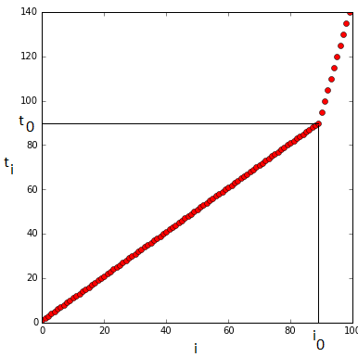

Fig. 1. Time indexes ti

Any Gaussian multivariate distribution can be characterized by its mean and covariance. In what follows, we shall considered that all the vector of interest are centered. We then have zero mean initially.

In our case, we shall assume a specific form for the covariance of any subsample (Xt1,…, Xtd) of our Gaussian process. More precisely, we assume that it can be expressed by (1).

|  |  |
| --- | --- |
|  | (1) |

Parameter *a* in kernel function (1) is a scale parameter, whereas the parameter *l* is a dispersion parameter. List of most popular kernels along with its covariance matrices for the given timeset T is presented on Fig. 4.

From one covariance matrix and one sequence of time (t1,…,tk) possible Gaussian distribution (Xt1,…, Xtk) with zero mean and covariance C (see Fig. 2) is shown on Fig. 3 (xti represents values of random variables, ti represents time indexes).

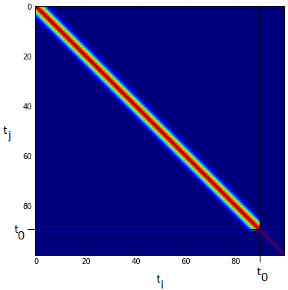

Fig. 2. Covariance matrix C

As we can see, the trend of generated samples is not spoiled by not equally spaced time indexes and can be easily seen.

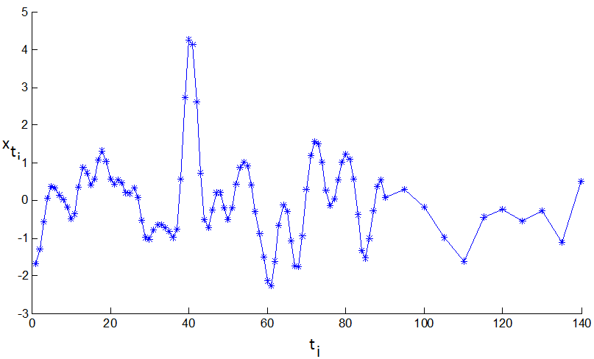

Fig. 3. One possible realization of multivariate Gaussian distribution

Now assume that we are conditioning our stochastic process for example setting xt1 = 1, xt2 = 1 with t1 = 40, t2 = 80. Computed the new mean vector and covariance matrix using equations (2) from [3] for multivariate conditional density, a new set of realizations of multivariate conditional distribution will be obtained (where f* – denotes the Gaussian vector x* = x{t ∈ T \ T’}, f – denotes the Gaussian vector xf = x{t ∈ T’} and K – covariance matrices associated to the two random variable sets X* = X{t ∈ T \ T’}, Xf = X{t ∈ T’} computed as K*,f = cov(X*,Xf), Kf,f = cov(Xf,Xf), Kf,* = cov(Xf,X*), K*,* = cov(X*,X*)).

|  |  |  |  |
| --- | --- | --- | --- |
|  | | | (2) |
| 1. Linear kernel:     where *k(x,y)* = *k*(xi,xj), σ2 = 1 – variance,  dimensionality of input vector x is (100 x 1) |  | |
| 2. RBF - Radial Basis Function kernel:    where *k(r)* = *k*(xi,xj), r2 = xi2+xj2, σ2 = 1 – variance  dimensionality of input vector x is (100 x 1) |  | |
| 3. Poly - Polynomial kernel:    where *K(x,y)* = *k*(xi,xj),  c = 0 – trading off parameter, d = 2 – power,  dimensionality of input vector x is (100 x 1) |  | |
| 1. RatQuad – Rational Quadratic kernel:     where *k(r)* = *k*(xi,xj), r2 = xi2+xj2,  σ2 = 1 – variance, α = 2 – power,  dimensionality of input vector x is (100 x 1) |  | |
| 5. MLP - Multi layer perceptron kernel:    where *k(x,y)* = *k*(xi,xj), xTy corresponds to xi xj,  σ2 = 1 – variance, σw2 = 1 – weight variance,  σw2 = 1 – bias variance,  dimensionality of input vector x is (100 x 1) |  | |
| 6. Matern32 - Matern 3/2 kernel:    where *k(r)* = *k*(xi,xj), r = sqrt(xi2+xj2),  σ2 = 1 – variance  dimensionality of input vector x is (100 x 1) |  | |

Fig. 4. Classical kernels and theirs covariance matrices

The example of the result of such process can be seen on the Fig. 5. As we can see from the plot all the random lines intersect at two points (40,1) and (80,1) which are our conditions. It means that we can fix some values of a Gaussian process, and that the resulting process is still Gaussian. This property is widely used in Gaussian process.

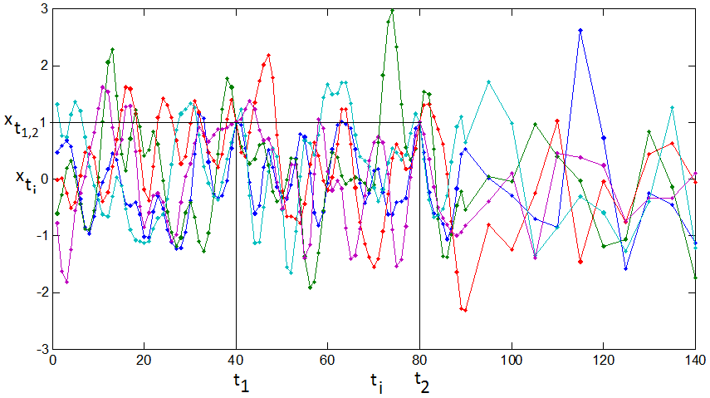

Fig. 5. 5 realizations of multivariate conditional Gaussian distribution

## 2. Gaussian process with latent variables

Gaussian process latent variable model is a new class of models which consists of Gaussian process mappings from a latent space X ∈ RQ to an observed data-space Y ∈RD, where Q << D, X, Y – multivariate Gaussian processes, through a set of parameters[6].

In a simplest case the output dimensions of Gaussian process latent variable model are a priori assumed to be linear, independent and identically distributed. In this case it can be interpreted as a probabilistic version of PCA.

Probabilistic PCA (PPCA) is a latent variable model in which the maximum likelihood solution for the parameters is found through solving an eigenvalue problem on the data’s covariance matrix. The relationship between the latent variable and the data point is linear with noise added. This relationship can be expressed by (3), where the matrix W ∈ RDxQ specifies the linear relationship between the latent-space and the data space and the noise values, ηn ∈ RDx1, are taken to be an independent sample from a spherical Gaussian distribution with mean zero and covariance β-1 I (4) [6].

|  |  |
| --- | --- |
|  | (3) |
|  | (4) |

The likelihood for a data point can then be written as (5). To obtain the marginal likelihood we integrate over the latent variables (6), which requires us to specify a prior distribution over xn. For probabilistic PCA the appropriate prior is a unit covariance, zero mean Gaussian distribution (7) [6].

|  |  |
| --- | --- |
|  | (5) |
|  | (6) |
|  | (7) |

The marginal likelihood for each data point can then be found analytically (through the marginalization in (6)) as (8). Taking advantage of the independence of the data points, the likelihood of the full data set is given by (9) [6].

|  |  |
| --- | --- |
|  | (8) |
|  | (9) |

The parameters W can then be found through maximizing (9). Marginalizing the latent variables and optimizing the parameters via maximum likelihood is a standard approach for fitting latent variable models [6].

## 3. Linear dynamical system

Consider a system of autonomous, first-order, linear difference equations (10) where the state variable xt is an n-dimensional vector, xt ∈ Rn, i,j = 1, 2, ..., n, and B is a n dimensional column vector of constant parameters, B∈ Rn. The initial value of the state variable x0 is given.

|  |  |
| --- | --- |
|  | (10) |

A solution to the multi-dimensional linear system (10) is a trajectory of the vector x that satisfies this equation at any point in time and relates the value of the state variable at time t, xt to the initial condition x0 and the set of parameters embodied in the vector B and the matrix A. Given the value of the state variable at time 0, x0, the method of iterations generates a pattern that constitutes a general solution (11) [11].

|  |  |
| --- | --- |
|  | (11) |

In this work dynamical texture modeling consists of two steps: dimensionality reduction and dynamic texture learning. They can be expressed as (12).

|  |  |
| --- | --- |
|  | (12) |

The first line of (12) is linear dynamic system such as presented below, where xt - latent variable which affects dynamic behavior, xt ∈ RQ, and instead of B in (10) nx,t in (12) - represent the noise, f() - dynamic modelling function RQ−>RQ , A - input parameters for function f(). Second line of (12) represents dimensionality reduction stage, where yt - column vector unfolded from the frame at time t, yt ∈ RD, D – large, Q<<D , g() - dimensionality reduction function RD−>RQ, B - input parameters for function g(), and ny,t - represents the noise [8].

## 4. Gaussian process dynamic model

The Gaussian process dynamic model (GPDM) is a latent variable model. It comprises a generative mapping from a latent space X to the observation space Y and a dynamical model in the latent space (Fig. 6). These mappings are, in general, nonlinear.

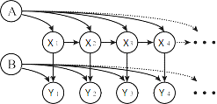

Fig. 6. Dynamical texture model

The GPDM is obtained by marginalizing out the parameters of the two mappings and optimizing the latent coordinates of training data [8].

In this work it is assumed that the dynamic texture sequence Yi is a multivariate Gaussian process indexed by Xi expressed by likelihood function (13), where Y – observed dynamic texture sequence vector, X – latent variable vector, KY – kernel matrix of latent mapping, D – dimensionality of original sample, N – number of frames in original sample [1].

|  |  |
| --- | --- |
|  | (13) |

To achieve nonlinear mapping special squared exponential covariance function (14) is used, where θ*i* – hyperparameters, δXi,Xj – Kroneker delta function.

|  |  |
| --- | --- |
|  | (14) |

At the same time, the latent dynamic behaviour changes among different types of dynamic textures. The second kernel function KX used in Gaussian process detects the dynamic behaviour of the latent variables. As for the kernel function itself, one of the functions from Fig. 4 can be taken. This second kernel comprises a generative mapping of dynamical model in the latent space, which defines this model dynamic.

## 5. Multi-kernel Gaussian process dynamic model

For dynamic texture modeling, the latent dynamic behavior varies greatly among different types of dynamic texture. Thus, it is very difficult to design the most suitable kernel for a dynamic texture empirically. To overcome this problem, a multi-kernel dynamic model for dynamic texture modeling is proposed [1].

In this model for the mapping of dynamic texture in the latent space kernel function (15) is proposed.

|  |  |
| --- | --- |
|  | (15) |

KX denotes the constructed kernel matrix generated by the multi-kernel function, where W – vector of weights of kernel functions K = kl, l ∈ [1,M], M – number of different kernel functions used.

In this case the likelihood function extends to (16), where Q – latent dimensionality, λ – set of parameters of kernels used in KX.

|  |  |
| --- | --- |
|  | (16) |

## 6. Mean-prediction method

The goal of the model proposed in this work is to generate new video data using learned dynamic texture. It can be done by estimating necessary parameters (latent variable vector, observed dynamic texture vector, kernel matrix mapping hyperparameters, weights for kernel functions and different kernel parameters) and then by predicting new sequence of dynamic texture.

As an approach to synthesize new data the adopted mean-prediction method based on first-order Markov model using Gaussian prediction is used in this work. In the prediction process, the latent variable xt is set to be the mean point given by the previous time index as (17) [1].

|  |  |
| --- | --- |
|  | (17) |

The mean point itself computes using equation (18) [1]. According to our model xt-1 must be used instead of X in (18), while X2:N and KX remain the same.

|  |  |
| --- | --- |
|  | (18) |

The new video sequence is then generated by (19), where mean and covariance for yt can be found throw (20), vector containing kY(x,xi) in the i-th entry [8].

|  |  |
| --- | --- |
|  | (19) |
|  | (20) | |

# Methodological contribution

First of all, implementation of Gaussian process linear model described in first part of Survey of the state of the art was done in Matlab. It helps to get better understanding and visualize of what is Gaussian process.

Moreover, reimplementation of the method in Jupyter notebook in Python was chosen as the way to get better understanding of the whole model. This approach implies to understand many things used in the method. They are sequence of steps of learning algorithm, functions which must be optimized, their gradients along with dimensionality analysis.

Learning Multi-kernel Gaussian process dynamic model algorithm is presented in [1]. It can be generalized in order to get easiest understanding into two main steps. First, we fix weights vector W and perform optimization of function (21) with respect to latent variable X, vector of hyperparameters θ of kernel KY and vector λ of kernels parameters of kernel KX with using Scaled conjugate gradient optimization method.

|  |  |
| --- | --- |
|  | (21) |

This function represents posterior distribution of our model. It is obtained from (17) by using Bayesian inference rules.

In second step, we fix obtained X, θ and λ and optimize function (22) with respect to W using gradient descent method. We do not need to use function (21) any more, we can simplify it to function (22), because once we fix X, θ and λ they become constant vectors and we can drop them (the minimum of the function does not depend on constants).

|  |  |
| --- | --- |
|  | (22) |

Due to the fact that functions (21) and (22) are not convex we must repeat these two main steps for I times, where I is fixed.

First kernel KY used for latent mapping (17) has dimensionality N by N. It can be easily derived as shown in (23).

|  |  |
| --- | --- |
|  | (23) |

Kernel KX used for dynamic modeling (16) has dimensionality N-1 by N-1. It can be easily checked as shown in (24).

|  |  |
| --- | --- |
|  | (24) |

To perform optimization all necessary gradients must be properly derived. General derivation is shown in Appendix A of [1].

To obtain gradient of function (21) with respect to X library functions for computing gradients for KY with respect to X1:N-1 and KX with respect to X1:N-1 must be used. The dimensionality of resulting gradient is N-1 by Q since dimensionality of gradient of (21) with respect to kernel functions KX and KY is N-1 by N-1 and dimensionality of library functions are N-1 by Q.

To obtain gradient of function (21) with respect to θ library function for computing gradient for KY with respect to θ must be used. The dimensionality of resulting gradient depends on dimensionality of hyperparameters vector θ.

To obtain gradient of function (21) with respect to λ library function for computing gradient for KX with respect to λ must be used. The dimensionality of resulting gradient depends on dimensionality of parameters vector λ.

Gradient of function (22) with respect to W is derived in (25). The dimensionality of resulting gradient depends on dimensionality of parameters vector W.

|  |  |
| --- | --- |
|  | (25) |

# Results

## 1. Matlab implementation properties

The implementation given in Matlab has several problems. First is inexplicable instability. The program crashes quite often with SVD computation error, as outcome you need to run it again using the same input and setting. It seems that method implemented for matrix inverse is not correct or one of the kernel matrices becomes not positive definite.

Second, sometimes the resulting dynamic texture is totally static while next run of the code generates not static texture. It can be explained by the following setup. In this experiment I used sample video **straw.avi** from Dyntex database [9] pre-processed to grayscale 120x90 pixels 10 seconds length (250 frames). Index of original pre-processed video are given on Fig. 7.

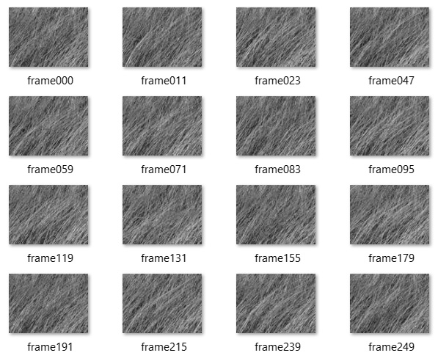

Fig. 7. Index of straw.avi sample video

In this setting program was run several times and every time the result was different. Weights obtained for kernels used for computing KX are presented in Tab. 1, kernel functions used in the implementation are presented in Fig. 8.

|  |  |  |  |  |  |  |
| --- | --- | --- | --- | --- | --- | --- |
| Attempt | **Linear** | **RBF** | **Poly** | **RatQuad** | **MLP** | **Matern32** |
| 1 | 0.040278 | 0.682626 | 0 | 0 | 0 | 0.277096 |
| 3 | 0.067891 | 0.720069 | 0 | 0 | 0.212038 | 0 |
| 7 | 0.003638 | 0.368365 | 0 | 0.345235 | 0.069727 | 0.213032 |

Tab. 1. Weights of different kernels after optimization with respect to different attempts

As we can see from Tab. 1 every time the result is different and Poly kernel is not used at all. It is contradictory to what is presented in [1] and it is inexplicable, because initial learning algorithm is deterministic.

|  |  |
| --- | --- |
| 1. Linear kernel:    where *k(x,y)* = *k*(xi,xj), σ2 = 1 – variance,  dimensionality of input vector x is (250 x 20) |  |
| 2. RBF - Radial Basis Function kernel:    where *k(r)* = *k*(xi,xj), r2 = xi2+xj2, σ2 = 1 – variance  dimensionality of input vector x is (250 x 20) |  |
| 3. Poly - Polynomial kernel:    where *K(x,y)* = *k*(xi,xj),  c = 0 – trading off parameter, d = 2 – power,  dimensionality of input vector x is (250 x 20) |  |
| 4. RatQuad – Rational Quadratic kernel:    where *k(r)* = *k*(xi,xj), r2 = xi2+xj2,  σ2 = 1 – variance, α = 2 – power,  dimensionality of input vector x is (250 x 20) |  |
| 1. MLP - Multi layer perceptron kernel:     where *k(x,y)* = *k*(xi,xj), xTy corresponds to xi xj,  σ2 = 1 – variance, σw2 = 1 – weight variance,  σw2 = 1 – bias variance,  dimensionality of input vector x is (250 x 20) |  |
| 6. Matern32 - Matern 3/2 kernel:    where *k(r)* = *k*(xi,xj), r = sqrt(xi2+xj2),  σ2 = 1 – variance  dimensionality of input vector x is (250 x 20) |  |

Fig. 8. Kernels and theirs covariance matrices with respect to latent variable X

To prove that the weights obtained are not correct the next experiment can be hold. In this experiment every kernel function from Fig. 8 is used separately. As sample video **straw.avi** from Dyntex database [9] pre-processed to grayscale 120x90 pixels 10 seconds length (250 frames) is used at the previous experiment. Index of original pre-processed video are given on Fig. 7.

The visual quality of the results obtained by using every kernel separately is contradictory to weights obtained in Tab. 1, but explains latent variable behaviour shown in Fig. 9. RatQuad, MLP and Matern32 kernels are able to capture dynamic texture, while other kernels cannot capture it at all and they provide static textures as a result. However, comparing between them RatQuad and Matern32 provide better result than MLP.

Finally, there is a problem with repetition of original sequences of frames in the results. It can be shown in the following setup using different video samples. In this experiment I used 4 different video samples from Dyntex database [9] preprocessed to grayscale 120x90 pixels 10 seconds length (250 frames). Indexes of original pre-processed videos are given on Fig. 7 (for straw.avi), Fig. 10 (for actinia.avi), 11 (for seawave.avi) and 12 (for sunshade.avi). Weights obtained after one standard run of the model are presented in Tab. 2. They can be easily compared using diagram given on Fig. 13.

|  |  |  |  |  |  |  |
| --- | --- | --- | --- | --- | --- | --- |
| **Sample** | **Linear** | **RBF** | **Poly** | **RatQuad** | **MLP** | **Matern32** |
| straw | 0.040278 | 0.682626 | 0 | 0 | 0 | 0.277096 |
| actinia | 0.289421 | 0.312588 | 0.076728 | 0 | 0.318424 | 0.00284 |
| seawave | 0.192753 | 0.318292 | 0.092731 | 0 | 0.396224 | 0 |
| sunshade | 0.511561 | 0.003422 | 0.008163 | 0 | 0.476782 | 7.18E-05 |

Tab. 2. Weights of different kernels for different samples after optimization

|  |  |
| --- | --- |
| 1. Linear kernel   Latent variables X1-X5 w.r.t. to time (obtained using linear kernel only – in blue, using all 6 kernels – in red) |  |
| 1. RBF kernel   Latent variable X1-X5 w.r.t. to time (obtained using RBF kernel only – in blue, using all 6 kernels – in red) |  |
| 3. Poly kernel  Latent variable X1-X5 w.r.t. to time (obtained using Poly kernel only – in blue, using all 6 kernels – in red) |  |
| 4. RatQuad kernel  Latent variable X1-X5 w.r.t. to time (obtained using RatQuad kernel only – in blue, using all 6 kernels – in red) |  |
| 5. MLP kernel  Latent variable X1-X5 w.r.t. to time (obtained using MLP kernel only – in blue, using all 6 kernels – in red) |  |
| 1. Matern32 kernel   Latent variable X1-X5 w.r.t. to time (obtained using Matern32 kernel only – in blue, using all 6 kernels – in red) |  |

Fig. 9. First 5 latent variables X obtained using different kernel functions separately

Visual quality is different for every sample and depends on dynamic texture itself. While *sunshade.avi* gives the best result, where rotation is seeing very accurately, but a little smooth, *actinia.avi* gives the worst result, where for the whole length of video actinia does not move at all.

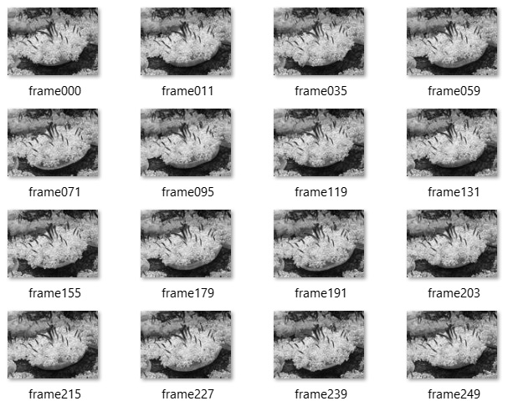

Fig. 10. Index of actinia.avi sample video

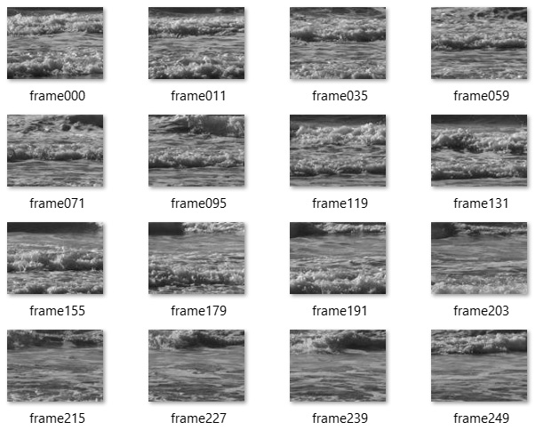

Fig. 11. Index of seawave.avi sample video

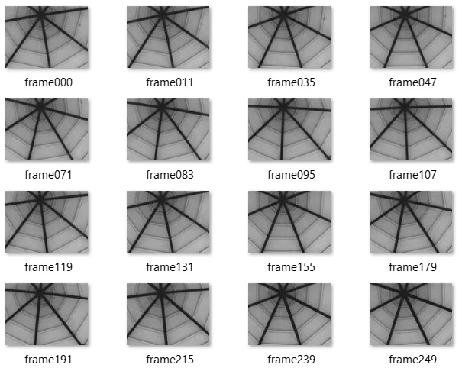

Fig. 12. Index of sunshade.avi sample video

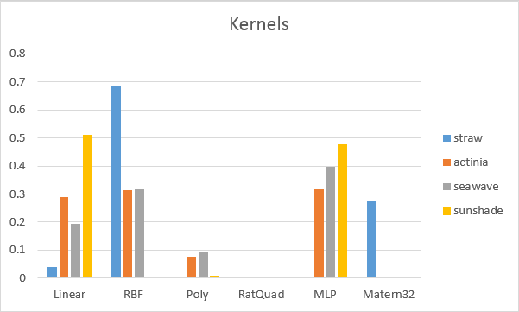

Fig. 13. Weights of different kernels for different samples after optimization

However, *seawave.avi* and *straw.avi* give quite acceptable result. Due to the fact, that the model uses mean prediction method instead of random process to generate new latent variables, the result of both of these videos has repetition of original frames sequences.

## 2. Python implementation properties

Gaussian process latent model (GPLVM) was implemented in Python. To model GPLVM, to build kernel function for latent mapping and to perform optimization GPy Gaussian process library [4] was used.

GPLVM models the joint distribution of the observed data and their corresponding representation in a low-dimensional latent space. Dimensionality of latent space was fixed to 20 as in Matlab implementation. For KX kernel construction combination of six kernel functions presented in Fig. 8 was chosen. As for optimization function Scaled conjugate gradient method was chosen as well. For synthesizing new sequence of latent variables mean prediction method is used along with multivariate Gaussian prediction for new dynamic texture synthesis.

GPLVM is not a dynamical model. In practice it means that there is no separate kernel function KY for dynamic modeling. Moreover, it assumes that data are generated independently, ignoring temporal structure of the input. However, the results are quite surprising. This method takes much more time for optimization comparing to Matlab implementation, but it is stable and it is able to generate new sequences of dynamic textures without visible repetitions.

For the experiments sample video **straw.avi** from Dyntex database [9] pre-processed to grayscale 120x90 pixels 10 seconds length (250 frames) was used. Index of original pre-processed video are given on Fig. 7. The result is presented in Fig. 14.

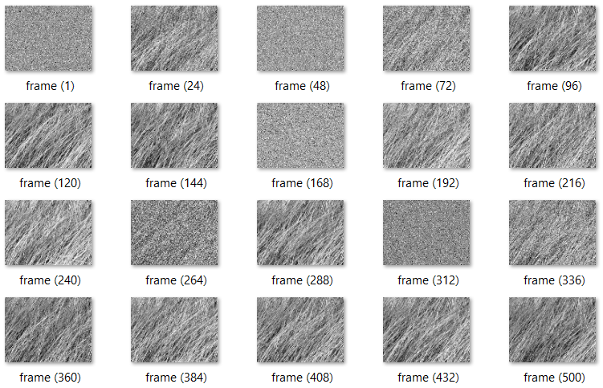

Fig. 14. Index of new generated dynamic texture using GPLVM in Python

The main drawback of this approach is that it takes a lot of time to perform optimization (around 1 hour using my personal laptop) and the visible result is still not good due to some random noise that can be seen on the frames.

# Conclusion and perspectives

The reimplementation of full Multi-kernel Gaussian process dynamic model in Python has not done yet due to the problems with gradients derivation. Without this information it is not possible to perform optimization. It could be interesting to finish this implementation and to compare the results with Matlab implementation.

The model does not provide numerical criteria for quality measuring. The visual evaluation approach is used only in paper [1]. It could be useful to develop and implement an evaluation method. Missing frames estimation approach can be used to realise this idea. However, it is not possible to perform estimation throw conditions on Gaussian process. Conditions are used to bound what we want to expect from the result. If we want to get one exact frame at time t we can input it as a condition. This model does not work in the opposite way. I could find a way to solve this problem.

Gaussian process latent variable model implementation is done and provides quite interesting result. Due to the high dimensionality of input data it takes a lot of time to perform optimization. It might be interesting to try wavelets to reduce dimensionality of original input samples in order to decrease the time of optimization and improve the quality of the result.

# Bibliography

1. Z. Zhu, et al., Dynamic texture modeling and synthesis using multi-kernel Gaussian process dynamic model, Signal Processing (2015), <http://dx.doi.org/10.1016/j.sigpro.2015.10.025>
2. R. Mourya, Modeling and Analyzing Dynamic Color Texture, Master Thesis Report, Université Jean Monnet, Saint-Etienne, France, 2012
3. N. Lawrence, Introduction to Bayesian Methods and Gaussian Process Regression, Conference on Computer Vision and Pattern Recognition CVPR 2012 - Providence, Rhode Island, USA, <http://www.cs.toronto.edu/~urtasun/tutorials/GP_tutorial.html>
4. N. Lawrence, Gaussian Process models with GPy, GP Summer School – Sheffield, 10-13th of June 2013, <http://gpss.cc/gpss13/>
5. N. Lawrence, Dimensionality Reduction using Gaussian Processes, GP Summer School – Sheffield, 10-13th of June 2013, <http://gpss.cc/gpss13/>
6. N. Lawrence, Probabilistic Non-linear Principal Component Analysis with Gaussian Process Latent Variable Models, Journal of Machine Learning Research 6 (2005) 1783–1816
7. G. Doretto, A. Chiuso, Y. N. Wu, S. Soatto, Dynamic textures, Int. J. Comput. Vis. 51 (2) (2003) 91–109, <http://refhub.elsevier.com/S0165-1684(15)00368-0/sbref15>
8. J.M. Wang, D.J.Fleet, A.Hertzmann, Gaussian process dynamical models for human motion, IEEE Trans. Pattern Anal. Mach. Intell. 30 (2) (2008) 283–298

<http://refhub.elsevier.com/S0165-1684(15)00368-0/sbref33>

1. R. Péteri, S. Fazekas, M. J. Huiskes, Dyntex: a comprehensive database of dynamic textures, PatternRecognit.Lett. 31 (12) (2010) 1627–1632, <http://refhub.elsevier.com/S0165-1684(15)00368-0/sbref34>
2. <https://en.wikipedia.org/wiki/Gaussian_process>
3. O. Galor, Discrete Dynamical Systems, Brown University, April 1, 2005.